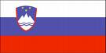

SLOVENIA HON. CONSULATE GENERAL
KARACHI.
D 90 Block 2Scheme 5 Clifton Karachi
Honorary Consul: MR Humayun Sultan Mufti
TEL: 5824184/85

The consulate is open only for information. Visa is process form Behran.

